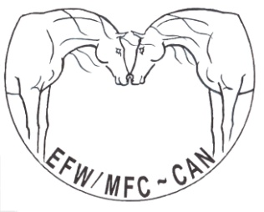
Equine Facilitated Wellness/ Mieux-Être Facilité par le Cheval -Canada
30 Bennett Street, Carleton Place, Ontario, Canada K7C-4J9
Fax: 613-257-2675
info@equinefacilitatedwellness.org www.equinefacilitatedwellness.org

Certified Professionals Event Submission Sheet

Please submit completed advertising template six weeks prior to the date you would like it published.

Eg. For a June 1st publishing date, you would submit your advertisement by April 15th at the LATEST.

Certified Professionals of EFW-CAN are encouraged to advertise upcoming events that will be marketed on the EFW-CAN website, in one edition of our newsletter and the EFW-Can Facebook page.
The advertising fee is included in your EFW-Can certified professional membership fee. Please fill in the below template and email it to info@equinefacilitatedwellness.org Submissions must be in six weeks before you would like it published. Incomplete submissions will not be accepted.
Name of Event
Date of Event
Event Description (maximum 200 Words)
Contact info and Link to Contact information for more event information/event registration
Please submit a Jpeg and PDF poster for the Facebook page and newsletter. Thank you for following our workshop submission template it helps us with congruency and scheduling. We look forward to seeing what our certified professionals have going on in their locations and to promoting the fabulous work we know you all are offering.

Revised February 2019

